

Name | Eivardas Puodziunas, Connor Brady, Kordian Mankowski,  Cathy Finn
Date | 02/04/2026
Student No | S00289971, S00288986, S00287201, S00291747
Student Email | S00289971@atu.ie , S00288986@atu.ie, S00287201@atu.ie, S00291747@atu.ie

Critical Analysis
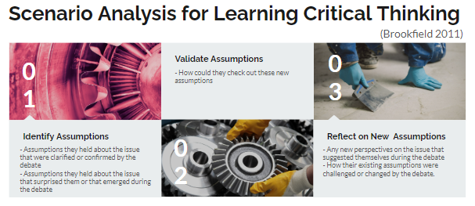
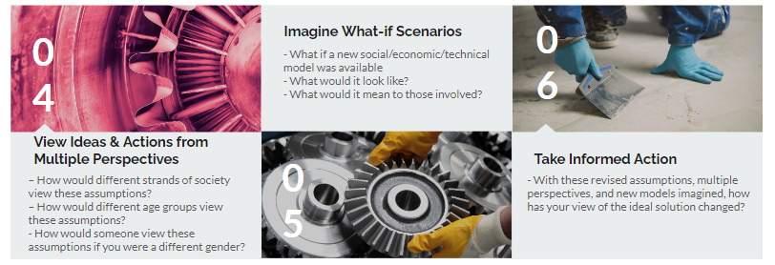

What *effect* does your system have?

On individuals?
1.Helps people to set up their alarms for cooking, waking up, etc.
2.Reduces Risk for Incorrect time.
3.Ease of use. You can stop the alarm with a button.

On society?
1.Shows that IoT can improve everyday devices.
2.Encourages Automation for homes and businesses.

1. Identify Assumptions
What assumptions did you make in designing your IoT system?
1.That users have wifi access.
2.That The alarm will be loud enough to wake the individual up/ alert them.
3.That the Users will know how to Use the button.
4.LCD display is readable in different lighting conditions.
5.Power supply is safe and not interrupted.

2. Validate Assumptions
How could you check whether these assumptions are true?
1.Test the system without internet access.
2.Let different users test the device.
3.Test the alarm in different sound conditions.
4.We need to run the alarm clock for long period of time to check reliability.
5.Compare the time on the alarm with the internet clock.

3. Reflect on New Assumptions
What new insights have you gained by identifying and validating your assumptions?
1.Internet may fail, System backup might be needed.
2.Some users may need multiple alarms.
3.People might need different alarm sounds.
4.Power outages might reset the system.
5.Not all users know how to use technology.

4. Consider Different Perspectives
How does your IoT system design, ideas & actions look from Multiple Perspectives e.g. perspective people of different ages, different socio-economic backgrounds, different genders, different types of business people, different types of investors, different nationalities, differently abled people etc?
1.Children: Might find it easy to use but might click the buttons accidently on the alarm clock.
2.Elderly: They might prefer bigger font and louder alarm.
3.Students/Workers: Will have great use from the alarm clocks accuracy.
4.Different countries: time zones will be needed to be handled with precision and accuracy.
5.People with disabilities: might need vibrations and ease of use for the alarm clock.

5. Imagine What-if Scenarios
Can you reimagine your IoT system, or the environments and people using, it to unlock new creative possibilities? What do you imagine could be possible in the future?
1.Sync with calendars and schedules.
2.batery backup for power outages.
3.connect to smart home devices such as lights so that the lights would turn on as soon as the alarm goes off.

6. Take Informed Action
Having gone through this Critical Analysis exercise, what would you change about your system and why?
1.Improve the UI so it looks neater and it would add a better user experience.
2.add multiple alarms feature so we wouldn't need to replace the current alarm every time.
3.Volume control so that it would be better experience for people that have good hearing or bad hearing.
4.batery backup for power outages so the alarm works properly in a power outage.

